Perfect. Here is a complete, thesis-grade methodology laid out as a clear pipeline — every stage explained at a level that builds your understanding as you go.
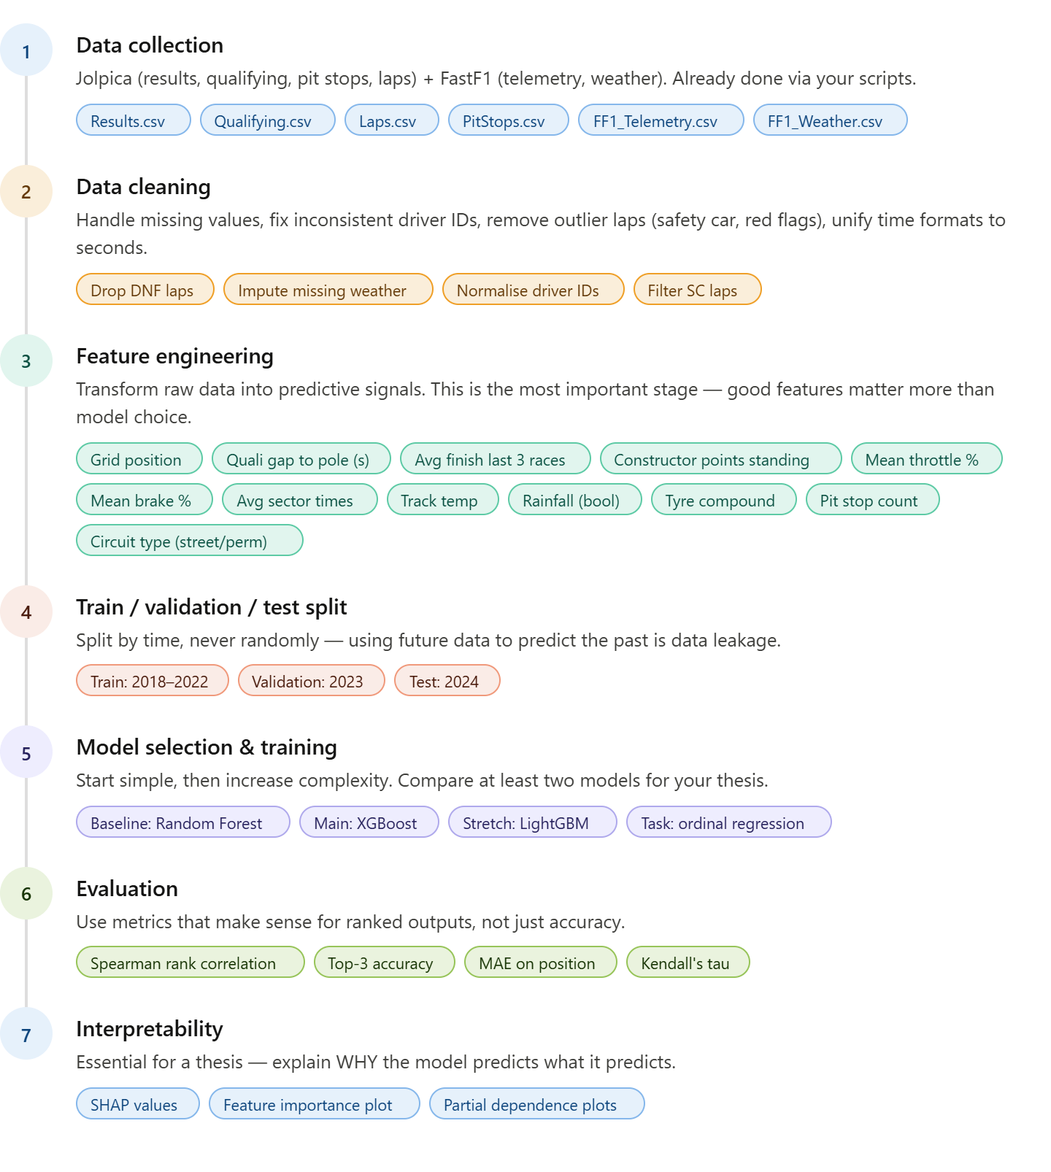
Here's a deep explanation of each stage:

Stage 1 — Data Collection
You've already done this. The key point is understanding what each source contributes to the prediction:
- Jolpica gives you the outcome labels (finishing positions) and structural race context
- FastF1 gives you the performance signals (how fast each driver actually was in practice and qualifying)
- Weather gives you the external conditions that affect tyre strategy and car balance

Stage 2 — Data Cleaning
The trickiest issues you'll face:
Safety car and red flag laps must be filtered out of any telemetry aggregations — a 120 km/h lap behind a safety car is not representative of a driver's pace. FastF1 provides a TrackStatus column for exactly this.
DNFs need careful handling — a driver who retired on lap 3 should not have their "average lap time" used as a pace feature. Either exclude them from pace features or impute using qualifying data.
Driver ID consistency — Jolpica uses strings like max_verstappen while FastF1 uses three-letter codes like VER. You need a lookup table to unify them before any join.

Stage 3 — Feature Engineering
This is where your thesis will live or die. Raw telemetry (800M rows) is useless to a model directly — you need to aggregate it into per-driver-per-race signals. The most powerful features will be:
- Qualifying gap to pole — how many seconds slower than the fastest driver. This is historically the single strongest predictor of race finishing position.
- Rolling average finish — driver's average finishing position over the last 3–5 races at the same circuit type (street vs permanent). Captures form and car development trajectory.
- Mean sector times from FP2/FP3 — a proxy for race pace before the race starts, since race telemetry is obviously unavailable at prediction time.
- Constructor championship position — encodes car competitiveness implicitly.
- Rainfall boolean — wet races are highly unpredictable and dramatically change the importance of other features.

Stage 4 — Train/Validation/Test Split
The most common mistake beginners make is a random 80/20 split. This causes data leakage — the model sees 2024 races during training and then "predicts" 2023 races, which is meaningless for a real-world system. Always split chronologically:
- Train: 2018–2022 (~100 races, ~2,000 driver-race rows)
- Validation: 2023 (used to tune hyperparameters)
- Test: 2024 (touched only once, at the very end, to report final results)

Stage 5 — Model Selection
For predicting a ranked finishing position, this is an ordinal regression problem (the outputs have a natural order: 1st is better than 2nd, which is better than 3rd). The recommended approach for a thesis:
Start with Random Forest as your baseline — it's interpretable, robust, and gives you a solid benchmark with minimal tuning.
Then train XGBoost as your main model — it consistently outperforms Random Forest on structured tabular data and has excellent support for feature importance. For position prediction specifically, use it as a ranking model (objective='rank:pairwise'), which is designed for exactly this type of ordered output.
Both are available in scikit-learn / xgboost with a few lines of Python.

Stage 6 — Evaluation
Standard accuracy is a poor metric here — predicting 2nd when the answer is 1st is far better than predicting 20th. Use metrics that respect the ordering:
- Spearman rank correlation — measures how well the predicted ranking matches the actual ranking. 1.0 is perfect, 0 is random.
- Top-3 accuracy — what % of the time is the actual winner in your predicted top 3? More practically meaningful for a thesis.
- MAE on position — average absolute error in positions (e.g., on average you're off by 2.3 places).

Stage 7 — Interpretability
A thesis requires you to explain your model, not just report its score. SHAP values (from the shap Python library) are the standard tool for this — they show exactly how much each feature contributed to each individual prediction, and you can produce charts showing which features matter most globally. This section can easily be a full chapter of your thesis.

Suggested Tech Stack
Task | Tool
Data processing | pandas, numpy
Feature engineering | pandas, scikit-learn
Models | scikit-learn, xgboost
Evaluation | scipy, scikit-learn
Interpretability | shap
Visualisation | matplotlib, seaborn
Would you like me to start writing the actual Python code for any of these stages — feature engineering, model training, or evaluation?

